TO SEE THE LIST OF FILES WE USE “ls” COMMAND

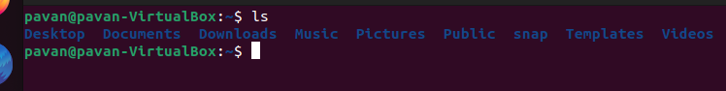

TO SEE THE LIST OF ALL FILES AND DIRECTORIES WITH THE TIME, PERMISSIONS AND ALL THE INFORMATION WE USE “ll “COMMAND, FOR THIS WE USE “ls

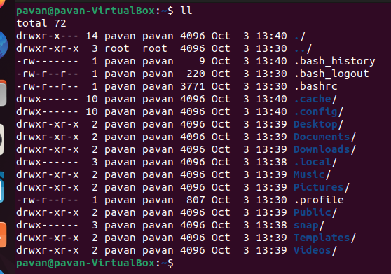

To see the present working directory we use command “pwd”

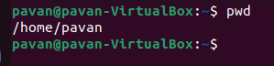

To create a new file use the command “touch filename”



To make a new directory use “mkdir directory name” and change the directory use “cd directory name”

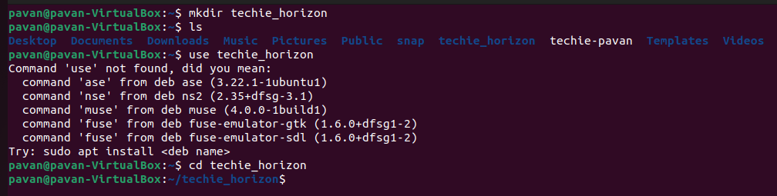

Change the directory use “cd directory name” and change the directory to pre directory use “cd..” and use “cd../..” for two pre directories

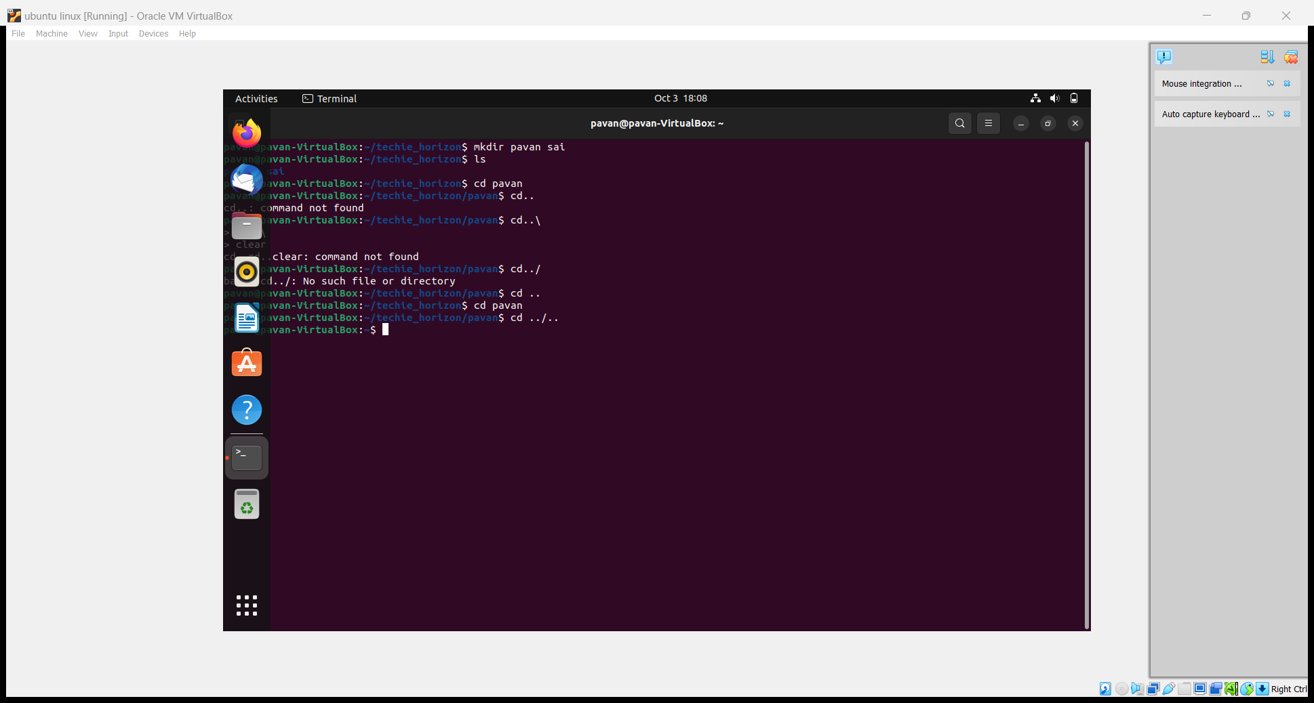

To delete the files use “rm filename”

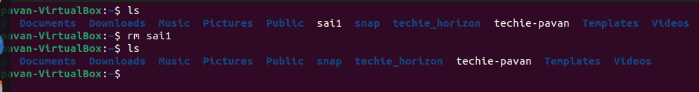

To delete the directory use “rmdir directory name”

